**자료구조론 CC343_2207**

**Programming assignment 5**

**경기대학교 컴퓨터공학부**

**201511837 이상민**

**Programming Example**

1번 문제  
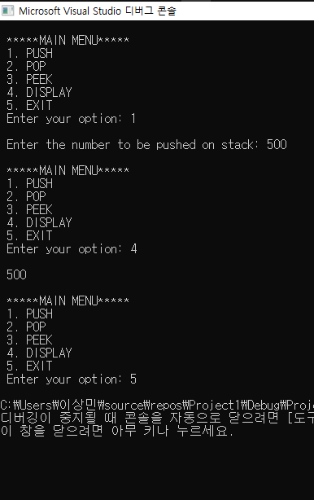

2번 문제  
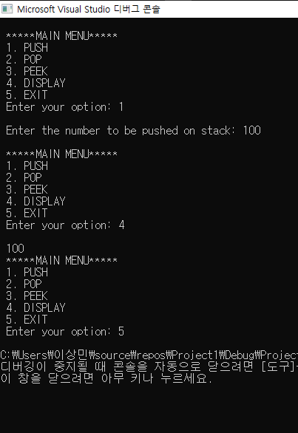

3번 문제  
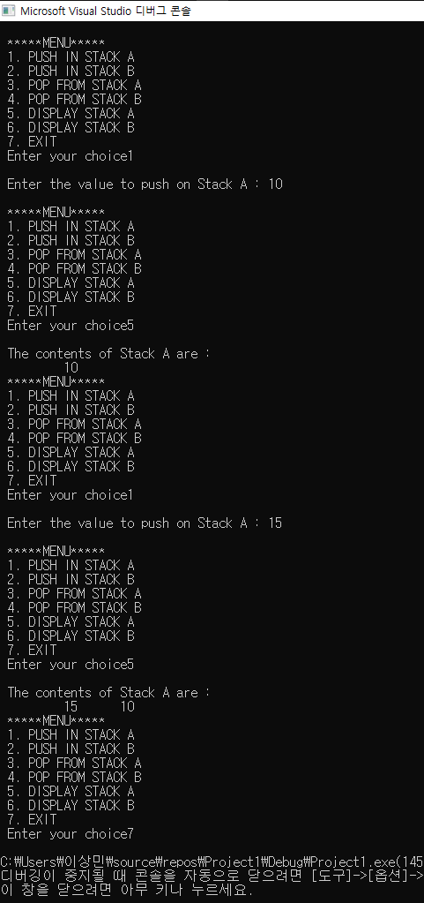

4번 문제  
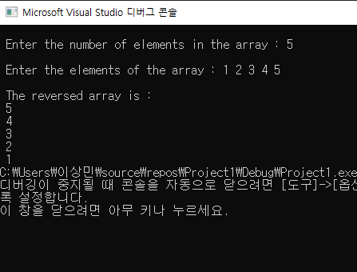

5번 문제  
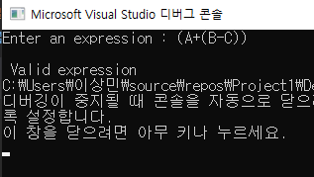

6번 문제  
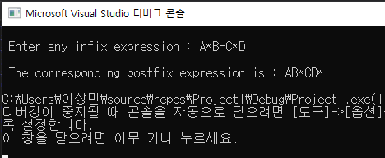

7번 문제  
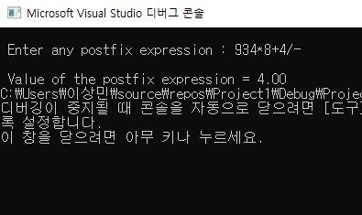

8번 문제  
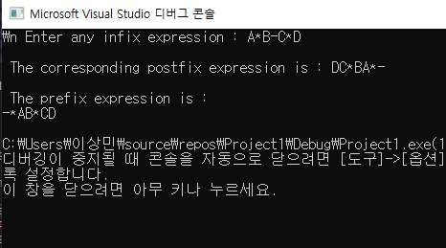

9번 문제  
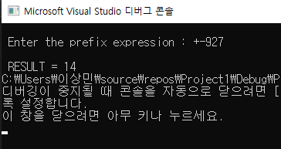

10번 문제  
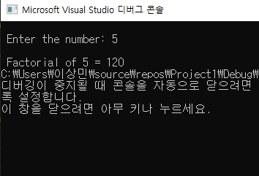

11번 문제  
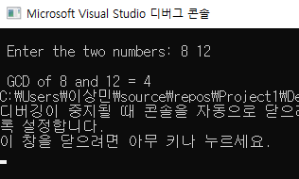

12번 문제  
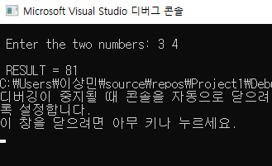

13번 문제  
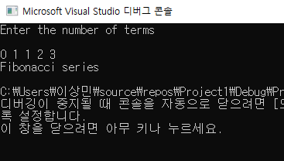

**Programming Exercises**

1. Write a program to implement a stack using a linked list.  
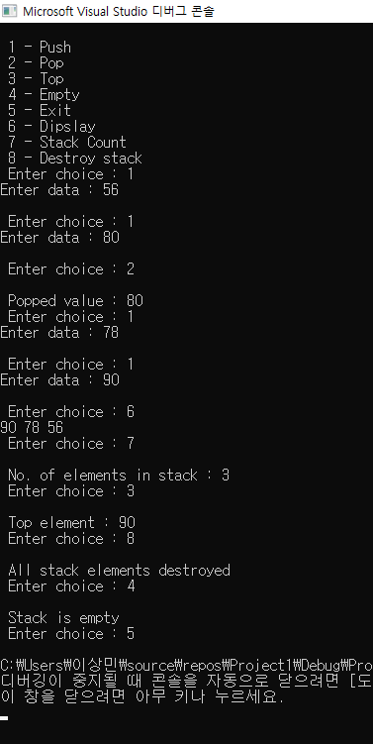

2. Write a program to convert the expression “a+b” into “ab+”.   
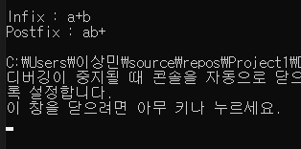

3. Write a program to convert the expression “a+b” into “+ab”.  
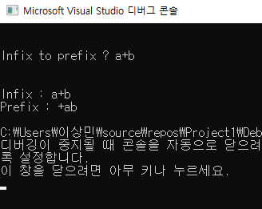

4. Write a program to implement a stack that stores names of students in the class.

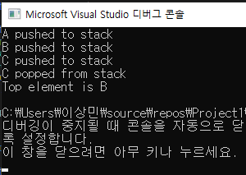

5. Write a program to input two stacks and compare their contents.  
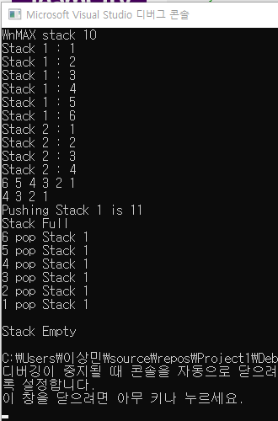

6. Write a program to compute F(x, y), where F(x, y) = F(x-y, y) + 1 if y<=x And F(x, y) = 0 if x<y  
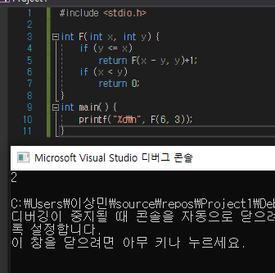

7. Write a program to compute F(n, r) where F(n, r) can be recursively defined as :

F(n, r) = F(n–1, r) + F(n–1, r–1)

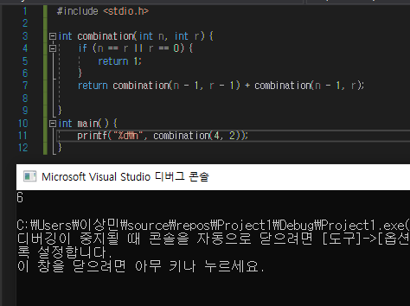

8. Write a program to compute Lambda(n) for all positive values of n where Lambda(n) can be recursively defined as :

Lambda(n) = Lambda(n/2) + 1 ( if n>1 )  
and Lambda(n) = 0 ( if n =1 )

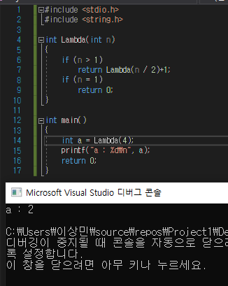

9. Write a program to compute F(M, N) where F(M, N) can be recursively defined as :

F(M,N) = 1 ( if M=0 or M≥N≥1 )

and F(M,N) = F(M–1,N) + F(M–1, N–1), otherwise

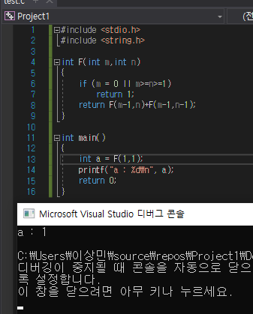

10. Write a program to reverse a string using recursion.

